*A Project Report*

*on*

**Text and Voice based Chatbot for Website**

*carried out as part of the course CS1634 Submitted by*

By

***Kumar Nilind***

***189301121***

***Shubham Maheshwari***

***189301129***

***VI-CSE***

*in partial fulfilment for the award of the degree*

*of*

**BACHELOR OF TECHNOLOGY**

In

**Computer Science & Engineering**



**Department of Computer Science & Engineering,**

**School of Computing and IT,**

**Manipal University Jaipur,**

***April 2021***

**Jaipur, Rajasthan**

**Abstract:**

Chatbot is an AI based or Rule based application used to communicate to a user via a computer program which makes it feel like the user is conversing to a human. Chatbots usually require a huge dataset of queries and responses to work well, with a reasonable amount of data for each type of query.

A small organization or an organization new to this approach might not have this data, our project is focused on these kinds of businesses. This Project uses a pattern matching approach to deal with the lack of data. Most of the data is already built into the Chatbot, any different kind of data like business related queries and other new intents can be added to the program with an excel file in a specified format.

Currently, the Chatbot system is built for MUJ Website for navigation. This Chatbot helps in providing course related details and helping in website navigation using links to the students who visit the website. The bot can reply according to the visitor’s query, including Course details, links to webpages, and can collect Contact information in case the visitor wants to contact the administration using Email or phone number. The bot has prebuilt intents to provide basic common functionality to the administrator.

**Table of Contents**

|  |  |  |  |
| --- | --- | --- | --- |
| **Sr. No.** | **Topic of Discussion** | | **Page No.** |
| 1. | Introduction | | 1 |
|  | 1.1 | Scope of Work | 1 |
|  | 1.2 | Product Scenarios | 1 |
| 2. | Requirement Analysis | | 1 |
|  | 2.1 | Functional Requirements | 1 |
|  | 2.2 | Non-Functional Requirements | 2 |
|  | 2.3 | Use Case Scenarios | 2 |
| 3. | System Design | | 3 |
|  | 3.1 | System Design Goals | 3 |
|  | 3.2 | System Architecture | 3 |
|  | 3.3 | Detailed Design Methodologies | 4 |
| 4. | Work Done | | 4 |
|  | 4.1 | Development Environment | 4 |
|  | 4.2 | Results and Discussions | 5 |
|  | 4.3 | Individual Contribution of project members | 5 |
| 5. | Conclusion and Future Plan | | 5 |

**List of Figures**

Figure 1. Conversational Flow diagram for the Chatbot used to demonstrate the System.

**1.** **Introduction:**

This document aims at defining the overall description of all the functions, and specifications for Text and Voice based Chatbot. The final product will have only features or functionality mentioned in this document.

The Chatbot is developed for organizations or businesses which lack the data and resources to build an AI Based Chatbot. The expected audience of this document is the faculty of Manipal University Jaipur (MUJ), including the person in a role of developing the Chatbot, database administrator and students of all disciplines of MUJ.

**1.1 Scope of Work:**

This Chatbot is designed for companies or businesses looking to build a chatbot for their website to reduce the workload of their customer care department and provide a satisfactory experience to the user. The chatbot can handle basic requests like fetching certain information or a webpage required by the user to access certain information. The Chatbot uses pattern matching in order

**1.2 Product Scenarios:**

Customers of those companies which have chatbot implemented on their website will engage in a conversation with the chatbot to resolve a particular query for which the company has uploaded the data. If there is an unresolved query, then the user will be requested for the required response. The Responses will be saved in a database and the admin will be notified about the query and is responsible to update the data to solve those unresolved queries or to filter out the garbage useless data that the User may provide, or the business might not require.

**2. Requirement Analysis:**

**2.1 Functional Requirements:**

**2.1.1 Chatbot Input and Interface:**

Chatbot should be able to receive voice or text-based input and should be easy to deploy on a website for which it is developed, without causing too much load on the server for loading a webpage. The Chatbot should also retain its text messages until the connection is dropped or is timed out, change of webpage should not affect the previously given input.

**2.1.2 Chatbot Response:**

Chatbot should be able to receive a textual or a verbal query, which can then be processed using a pattern matching algorithm and according to the matched intent and the current state of conversation, the bot will respond to the query with some predefined responses or perform an action based on the query.

**2.1.3 Dataset Management:**

Chatbot will allow the admin to upload the data in a specific format to formulate queries and responses and set the conversation flow for the Chatbot. The dataset for business specific queries should be available while developing the Chatbot if the organization wants the Chatbot to respond to specific queries according to their business.

**2.1.4 Data Collection for Self-Learning:**

Chatbot will store all the unresolved and new queries in an excel sheet and present them to the admin, then the admin will have to assign an intent to those queries or reject a response if it is unrelated to the company. This is done because the User might inexplicably give incorrect responses which will also be saved to the table, but these inputs cannot be used to improve the Chatbot and might also cause it to return invalid responses.

**2.1.5 Multiple Algorithm Support:**

The Chatbot can work with Pattern Matching or using Artificial Neural Networks, for intent classification of the queries. This makes the Chatbot more capable to work with different sizes and different types of datasets available to a business.

**2.1.6 Voice based Input and Responses:**

Chatbot will be able to communicate to the user using voice-based input and respond back in voice based output using an API to convert Text to Speech and Speech Recognition.

**2.2 Non-functional Requirements:**

**2.2.1 Compactness:**

Chatbot should be small to not hinder the functionality of the website itself. Addition of new data should be prohibited into the chatbot database if it makes the website work slower.

**2.2.2 Security:**

Only the admin should be allowed to update the chatbot’s data. No one other than admin should be allowed to tamper the data.

**2.2.3 Performance:**

The response time should be low, and throughput of the system should be high for the customers that have a conversation with the chatbot.

**2.3 Use Case Scenarios:**

**2.3.1 Querying Chatbot and returning a response, Text based:**

Customers will ask a query to the chatbot in Textual form and wait for a few seconds for the chatbot to process and respond to take the conversation further. In case the query is out of scope for the Chatbot, users can then assist in improving that query by submitting a response and query to the Chatbot, which will be stored in a database table. If the query is found then the Chatbot will ask further information from the user, if required or not already provided.

**2.3.2 Querying Chatbot and returning a response, Voice based:**

Customers will ask a query to the chatbot in Vocal form and wait for a few seconds for the chatbot to process and respond to take the conversation further. In case the query is unrecognizable then the User is asked to say the query again. If the Query is out of scope for the Chatbot, users can then assist in improving that query by submitting a response and query to the Chatbot, which will be stored in a database table. If the query is found then the Chatbot will ask further information from the user, if required or not already provided.

**2.3.3 Upload Chatbot Data:**

Admin will upload the chatbot business specific data from which the queries and responses will be formed and decide the conversation flow for the chatbot, using the helper functions of the module. The data must be in a specific predefined format to be uploaded correctly.

**2.3.4 Update Chatbot Data:**

Admin can update the chatbot data when it has been collected. The Admin will work as a filter to remove false or Out of Scope queries to make sure the Bot responds in the correct way.

### **3. System Design:**

**3.1 Design Goals:**

The Chatbot is designed in such a way that it could handle the following goals:

1. Chatbot should be designed in a way to quickly respond to the customer.
2. Chatbot should be designed in a way to have less memory load on the system/ website.
3. Chatbot Interface should be user-friendly for both Admin and the User.
4. Data Collection should be available for Out-of-Scope user queries to develop a better and more flexible response system.

**3.2 System Architecture:**

System will be designed for a website in a client-server manner, like a messaging app. Client and server will be connected using WebSockets to speed the process of communication using asynchronous requests and remove the slow and synchronous process of http requests. Asynchronous means anyone can communicate with the other directly, without any delay or requests. Major Processing tasks will be done at backend, only the response will be sent to the Users in an asynchronous manner to the interface.

The backend can perform basic pre-processing of the data using Python Natural Language Processing libraries, and the result is pattern matched using regular expressions. The patterns can be loaded from a json file which is already implemented to work for basic queries for the user. The patterns found in the database are also checked for synonyms using the Wordnet module from Python’s Natural Language Toolkit Library (nltk). Wordnet is used to provide more flexibility in detecting the user query. Since the backend also supports Self-Learning data collection, the Chatbot will be able to save certain interactions from the user in a SQLlite3 Database table.

The Chatbot uses a well-defined conversation flow to maintain a conversation, which is shown in the given figure:

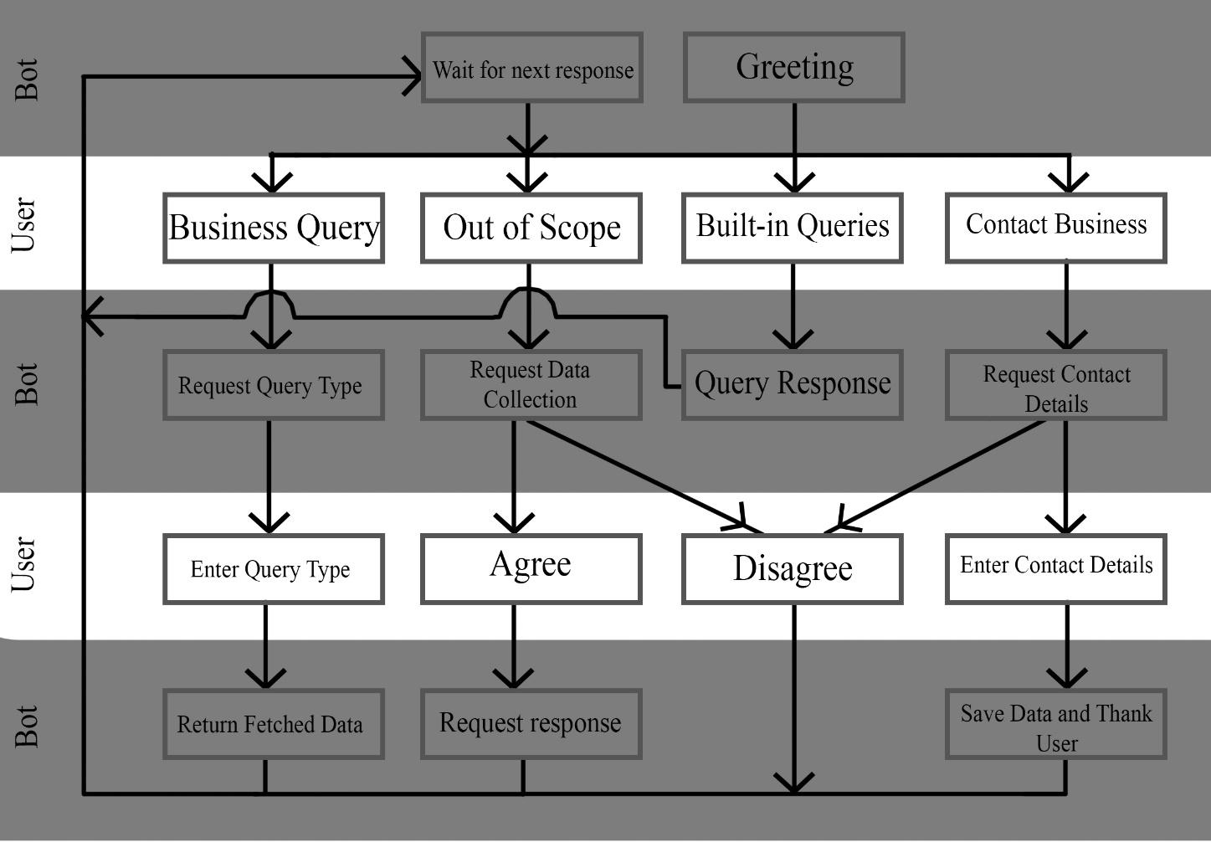

**Figure 1: Chatbot Conversational Flow**

The Built-in Queries is meant to represent all the queries like, User Greetings, Thanks, Goodbye, or any other type of query that will not have a functionality and is already built in into the system.

**3.3 Detailed Design Methodologies:**

**3.3.1 Module based approach:**

The Chatbot is developed as a single module generalized to work with different available resources. This module is then demonstrated using the MUJ Course Dataset. The Chatbot is then able to find and respond to user queries related to courses and their details. This module is independent of the specific data required to build it.

**3.3.2 Pattern Matching:**

The Query from a user is received from frontend and then processed to make sure general out of Vocabulary symbols and special characters are removed. The input is also converted to lower case alphabets. This input is then matched through a pattern matcher for multiple words present in the dataset of the chatbot, if the chatbot contains any of these words, the intent is recorded. If none of the intents match, then an Out of Scope intent is added which can be further used to record data. Pattern matching system is necessary to know which action to perform with a given user response.

**3.3.3 WordNet:**

Pattern Matching on its own is quite rigid and straightforward, if a user uses words that are not in the Chatbot’s vocabulary then it will be registered as out of scope. To prevent this from happening in most basic requests and overall reduce the typing effort of the developer. A system is called WordNet, it is a small database in Python’s NLP Toolkit which helps in getting similar words or synonyms of words in a query. This makes the system more flexible and allows for a larger vocabulary.

**3.3.4 WebSockets:**

WebSockets are full-duplex persistent connections from Client to Server, which used to Asynchronously communicate from server to clients, that is send messages to each other at any time without any requests. These are used in our interface to provide a working system on which our chatbot could work in.

**3.3.5 Voice Recognition:**

The Chatbot can recognize voice and convert it to text using Web Speech API. This API is integrated with the interface to provide voice-based input and output to the user using two components SpeechRecognition for voice input and SpeechSynthesis for voice output.

**3.3.6 Lemmatization:**

The Queries in the chatbot are preprocessed before it is entered to the database or when a user query is classified. This helps in reducing the load on the system by having less words to check and lesser features to deal with overall. As Lemmatizer converts similar words to a single word.

**3.3.7 Artificial Neural Networks:**

Artificial Neural Networks are used for relatively smaller datasets but still larger enough to be very slow for pattern matching algorithms, this allows us to have a much-varied datasets to be easily classified at a very fast pace with the need to check all the intents one by one at the cost of a very small percentage for wrong classifications (0.2%).

**4. Work Done:**

**4.1 Development Environment:**

The following development software have been used:

1. Python Version 3.7 is used to develop the Chatbot.
2. The intents are stored in a json file, to produce a dictionary to provide faster results.
3. Database used is SQLlite3 for faster and simple usage as it is already commonly available and easily imported in Python.
4. Flask will be used with the Chatbot using WebSockets to create a user-friendly interface for chatbot responses and user queries.
5. Tensorflow is used for creating the neural network and the Chatbot model.
6. Natural Language Toolkit (nltk) is used for Natural Language Processing of the data for stuff like Tokenization and Lemmatization.
7. Web Speech API has been used for Voice based System.

**4.2 Results and Discussion:**

This Project develops a generalized framework to produce a working Chatbot, which can be easily customized using built-in methods. The Project can produce output of basic general queries like Greetings and Thanks on its own. Business specific queries data can be added using the built-in functions of the Chatbot module.

To demonstrate its capabilities, we have developed a basic textual chatbot to operate on Manipal University Jaipur’s official website containing information about the courses available and their eligibility and duration for each course.

**4.3 Individual contribution of project members:**

Work Done by:

* Kumar Nilind
  + Literature Review for the best methodologies
  + Designing the Conversation flow
  + Developing the frontend of the Interface
  + Text based Chatbot (Pattern Matching and ANN Modules)
* Shubham Maheshwari
  + Literature Review for the best methodologies
  + Business facing queries handling
  + Backend interface
  + Voice based extension
  + Admin Interface and Management System

**5. Conclusion and Future Work:**

Chatbot is still a developing field with much yet to be discovered, therefore we are still applying some of the recently developed approaches of these systems for businesses that are still new to this field. This project is based on Voice and Text input which can be integrated with a website to function as a customer care/ enquiry bot for a business or organization. The Chatbot is aimed specifically at organizations that do not have the data to develop a complex system but would also like to have a system which can reduce the mundane and repetitive task of customer care for basic requests from customers.

In future, this module can be extended to have its own self learning system which after collection of a good amount of data, can be used to have an AI based approach, which is faster and more effective in replying to users. The self-learning module can also be extended to receive data from external sources which can also be used to train a Neural Networks to classify the queries of users. Furthermore, the voice recognition system can be made more robust and quicker if the company has access to their own or a faster API which can be used to convert voice to text on the server side itself.